JAVA MINI PROJECT
Name: Soumya Suryawanshi
Prn: 2407052101062
Sem: 4th A
Topic: Student Management System

1. Student Management System
Problem statement
Develop a Java application that demonstrates the concept of inheritance for managing student information. Begin by creating a base class named Person, which contains general attributes such as name and age. Extend this class into a derived class called Student, adding specific details like roll number and marks. Further, create another subclass named GraduateStudent that includes additional information such as the field of specialization. The program should effectively utilize inheritance to display complete details of a graduate student, incorporating properties from all parent classes.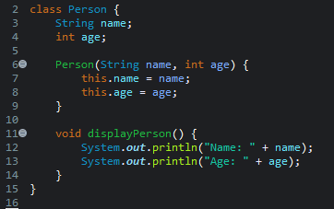
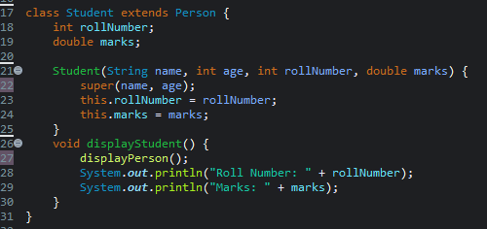
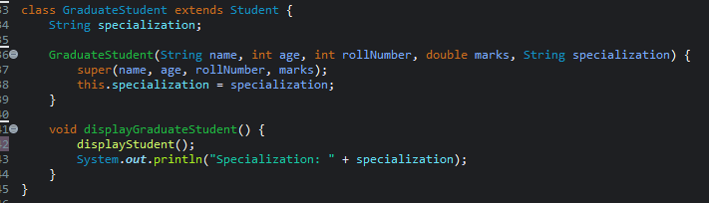
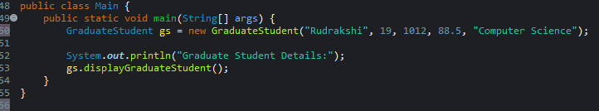
OUTPUT:
